

project file

STUDENTS LIFESTYLE DATASET

SUBMITTED TO:

MR. SOURABH SIR

SUBMITTED BY:

Aanchal Tomar

MBA 1st year

Section – A

CU24140082

TITLE :- STUDENT LIFESTYLE INSIGHTS REPORT

Name :- AANCHAL TOMAR

Registration Number :- CU24140082

Course :- MBA

Semester :- 1st SEMESTER

Section :- A

Submission Date :- 26th November 2024

Faculty Name :- MR. SOURABH SIR

**Executive Summary**

* **Project Objective:**

The objective of this project is to analyse user behaviour, engagement, and productivity trends based on a comprehensive dataset that includes demographic, behavioural, and platform-specific information.

By examining key variables such as user age, gender, location, income, and profession, alongside digital interaction data like total time spent, number of sessions, video category preferences, scroll rate, and frequency, the project aims to uncover patterns and correlations in video consumption and user engagement.

* **Methodology:**

1. Data Cleaning & Preprocessing: The data was pre-processed by removing duplicates and handling any missing values. Additionally, data types were set correctly to ensure smooth analysis.
2. Power BI Functions: Several Power BI functions were utilized:

Slicer, Card, Sum and Average, Visuals (Charts and Graphs

1. Dashboard Creation: An interactive and visually appealing dashboard was created that allowed users to:

* **Key Findings:**

• **Outcome:**

The dashboard provides a clear, user-friendly interface to analyse student performance.

**TABLE OF CONTENTS**

Introduction

* Context of the Project and its importance
* Objectives

2. Data Overview

* Data Sources
* Data Description
* Data Preparation

3. Power BI Process

* Dashboard Design
* Data Modelling
* Visualizations

4. Insights and Analysis

* Dashboard creation
* Key Insights
* Visualization
* Dashboard features

5. General Power BI Limitations

6. Limitations and Recommendations

7. Conclusion

**INTRODUCTION**

* **Importance**

This This project focuses on analysing a dataset containing information about students' daily routines and its impact on their academic performance and stress levels. The dataset includes details like **Student ID**, which uniquely identifies each student, along with key activities such as **study hours per day**, **extracurricular activity hours per day**, **sleep hours per day**, **social hours per day**, and **physical activity hours per day**.

Additionally, it captures the students' **GPA**, which represents their academic performance, and their **stress levels** to understand their mental well-being.

By using Power BI, the dataset is explored to identify patterns, correlations, and insights that can help improve students' productivity, health, and academic outcomes. This analysis aims to provide actionable recommendations for maintaining a healthy balance between academics and personal life.

* **Objective**

The primary objective of analysing this dataset in Power BI is to understand how different aspects of a student’s daily routine influence their academic performance and stress levels. This analysis can help:

* Identify key factors contributing to higher GPA and reduced stress levels.
* Visualize the balance between study, extracurricular, and personal activities for optimal well-being.
* Provide actionable insights for students, educators, and parents to improve academic outcomes and mental health.

**DATA OVERVIEW**

**Data Overview: Student Lifestyle Analysis**

* **Data Source**: (Excel Files)

The use of Excel files as the primary data source plays a critical role in this project. Excel is widely used for data storage and manipulation, making it easily accessible for many businesses. In the context of Power BI, importing Excel data offers flexibility, enabling the creation of dynamic and interactive dashboards. This seamless integration allows users to perform extensive data analysis, ensuring accurate and real-time decision-making.

* **Dataset Description:**

The dataset contains 2000 rows and 8 columns, providing detailed information about Student lifestyle.

The dataset includes the following key variables:

1. **Student ID:** A unique identifier for each student in the dataset.
2. **Study Hours Per Day:** The average time a student spends studying daily.
3. **Extracurricular Activity Per Day:** The amount of time spent on extracurricular activities such as music, arts, or clubs.
4. **Sleep Hours Per Day:** The daily average number of hours a student sleeps.
5. **Social Hours Per Day:** The time a student dedicates to socializing with peers or family.
6. **Physical Activity Hours Per Day:** The duration of physical activities like sports or exercise.
7. **GPA (Grade Point Average):** The academic performance indicator of each student.
8. **Stress Level:** A metric (qualitative) indicating the stress levels experienced by the student.

* **Data Preparation**

The data preparation process involved several crucial steps to ensure the dataset was ready for analysis:

**1. Data Cleaning:**

Objective: Ensure the dataset is complete, accurate, and ready for analysis.

* Remove Duplicates
  + Check for duplicate entries in the Student ID column.
  + Remove duplicates to avoid over-representation of any student.
* Handle Missing Values
  + Identify missing values in critical columns like GPA, Stress Level, or activity hours.

1. **Data Transformation:**

* Data Standardization
* Standardized column headers and formats, ensuring consistency in units.
* Categorical Grouping
* Grouped similar categorical values (e.g., sleep hours per day , social hours per day) to simplify analysis and improve dashboard readability.

**Objective:**

The main goal is to derive insights from the dataset that can help an students make best decisions and create strategies. Using Power BI, various functions and visuals will be applied to develop an attractive dashboard for better decision-making.

**INSIGHTS AND ANALYSIS**

* **Dashboard Design**

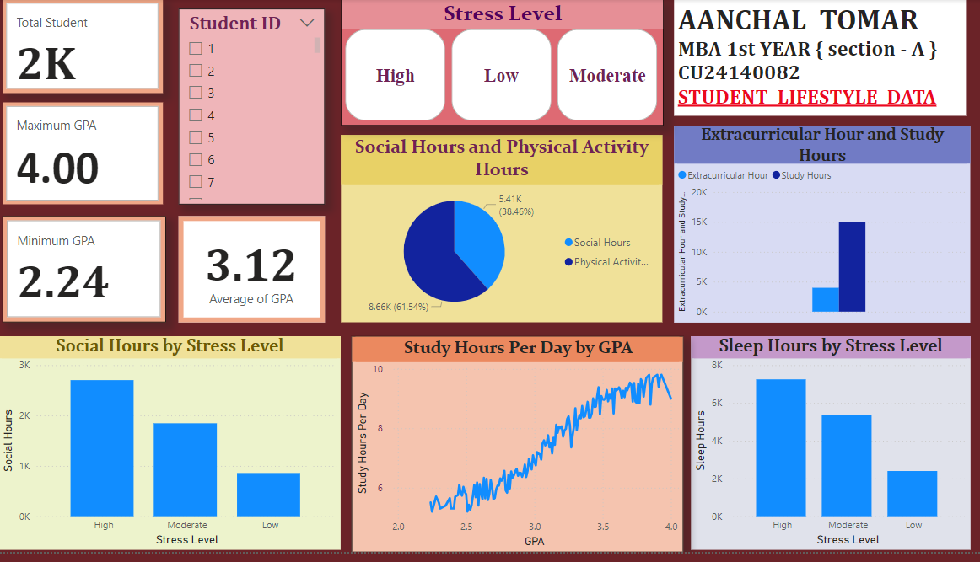

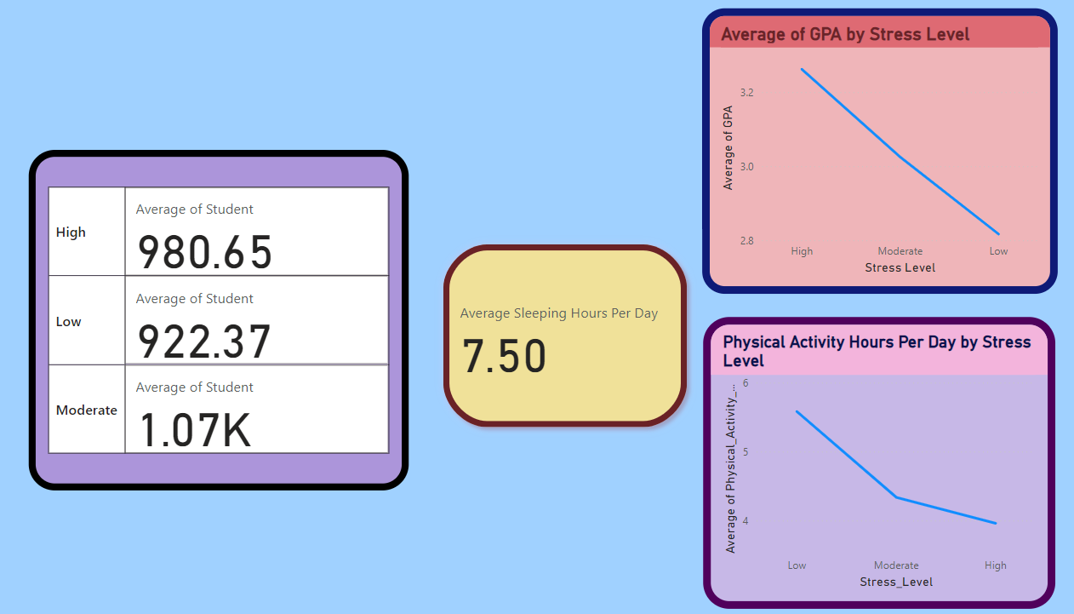

**Dashboard Creation**

* Arrange visuals aesthetically.
* Use cards to display key KPIs:
  + Average GPA
  + Maximum GPA
  + Average Stress Level
  + Average Study Hours
* Add a slicer for interactive filtering.

Useful Insights

Using Power BI's various functions, several insights can be derived from the dataset to aid students decision-making and strategy development.

**Useful Insights and Analysis**

1. Impact of Sleep hours on stress level

* Check if students with 7–8 hours of sleep tend to have higher or lower stress levels, using a **clustered bar chart**.

1. Relation between study hours per day and GPA

* Analyze how the number of hours spent studying per day affects GPA.
* Used a **line chart** to visualize the relationship.
* Create a trend line to see if increased study hours improve GPA consistently.
* When Average study hours is **7.98** then GPA is only **3.23**

1. Effect of Extracurricular Activities on Study hours per day

* Segment students based on the hours spent on extracurricular activities and calculate their average GPA.
* Use a **stacked bar chart** to show the trade-off between extracurricular activities and academic performance.
* Its shows average extracurricular activity hours is **1.99** and the average GPA of students is **3.12**, so the academic performance is higher.

1. Social Hours vs Stress Levels

* Analyse the relationship between social hours per day and stress levels.
* Students whose average social hours is **2.74** hours having **moderate stress level**
* Identify an optimal range of social interaction that helps reduce stress without negatively impacting GPA.

1. Social Hours vs physical activity

* Use a pie chart to show average physical activity hours and average social hours spend , average social hours is **2.70 ( 38.46%)**whereas physical activity hours is **4.33 ( 61.54%)** .
* Segment data to highlight students who balance physical activity and a social hours well.

1. Physical Activity and Stress Management

* Use a line chart to show how physical activity hours correlate with lower stress levels. Students whose average physical activity **4.34** hours having **moderate stress** level.
* Segment data to highlight students who balance physical activity and academics well.

1. GPA and stress level
2. Maximum GPA – Max Function is used for calculating the maximum GPA of student’s that is **4.00**.
3. Minimum GPA - Min Function is used for calculating the minimum GPA of student’s that is **2.24**.
4. Average GPA - Average function is used for calculating the Average GPA of student that is **3.12**.
5. Average sleep hours per day - Average function is used for calculating the Average sleep hours per day of student that is **7.50 hours**.
6. Slicer Function – It is used in the Student’s Id to get the data individually.
7. Count function - count function is used for calculating the total number of student that is **2k (2000)** .

**Key Insights to Derive:**

1. Correlation Analysis:
   * Relationship between study hours and GPA.
   * Impact of stress level on GPA and other activities.
2. Balance Analysis:
   * The balance between study, sleep, extracurricular, social, and physical activities.
3. Categorization:
   * Identify students with balanced lifestyles vs. those who are stressed or underperforming.
4. Trend Analysis:
   * Patterns in activities for high-performing vs. low-performing students.

* **Visualization**

**Power BI Functions and Features Used:**

**Visualizations:**

* Clustered Column Chart:
  + Display the total study hours, social hours, or physical activity hours per day using bar or column charts.
  + You could compare GPA vs. study hours or GPA vs. hours of sleep.
  + Use a scatter plot to show the relationship between "study hours" and "GPA" or between "stress level" and "sleep hours".
* Pie Charts:
  + Use pie charts to visualize the distribution of social hours and physical hours spend by students per day.
* Line Chart:
  + A line chart could show trends, such as how study hours vary across different GPA categories.
* Card Visual:
  + Use card visuals to show KPIs like average GPA, average stress level, or average total hours spent on activities.

**Dashboard Features:** The Power BI dashboard is designed to be user-friendly, visually engaging, and informative, offering an intuitive view of:

* metrics and key performance indicators (KPIs)
* Interactive filters to explore the dataset from different angles.
* Regional performance maps of students.
* Trends and patterns across different dimensions.

**Limitations and Recommendations**

* + 1. Student ID
* Limitation: Student IDs are unique identifiers, so they don't carry much analytical value for comparison or trend analysis. They are used to distinguish records, but including them in visualizations can clutter the dashboard or lead to confusion if not handled correctly.
* Recommendation: Use Student ID only as a filter or in specific scenarios (e.g., to track individual progress).

2. Study Hours per Day

* Limitation: Study hours are self-reported and may not be accurate due to biases, such as students overstating or understating their study habits. Also, study hours may vary significantly based on the student's course load or external factors (like exams).
* Recommendation: Ensure to clean and validate the data, check for outliers, and allow for comparison across categories like GPA or stress level.

3. Extracurricular Activity Hours per Day

* Limitation: Like study hours, extracurricular hours are also self-reported, and their impact on academic performance or stress can be subjective. Some students might be engaged in different types of activities (sports, arts, clubs), making it difficult to standardize the data.
* Recommendation: Categorize extracurricular activities into different types to give more context, and analyze the effect on GPA or stress more granularly.

4. Sleep Hours per Day

* Limitation: Sleep hours can vary from student to student and may not reflect actual sleep quality, which could be a more important factor affecting stress and GPA. Self-reported data may also be inaccurate.
* Recommendation: Focus on sleep consistency (e.g., average hours over a week) and correlate it with stress and GPA.

5. Social Hours per Day

* Limitation: Social hours could vary depending on what students consider "social," and excessive socializing could negatively affect academic performance. However, some level of social interaction is beneficial for mental health. The impact of social hours on GPA or stress may not be linear or obvious.
* Recommendation: Perform correlation analysis to assess how social hours influence stress levels or GPA, and consider categorizing social activities (e.g., group study vs. leisure time).

1. GPA

* Limitation: GPA may not fully capture academic success or stress levels, as it's a single metric. It also might not be comparable across different universities or courses.
* Recommendation: Use GPA in combination with other factors (e.g., study hours, extracurricular activities) for more holistic insights.

1. Stress Level

* Limitation: Stress levels are subjective and can be self-reported, so they may not accurately reflect a student's true stress. Stress is also influenced by many factors outside the scope of the dataset, such as personal life or financial issues.

**General Power BI Limitations**

1. **Missing Data**: Missing or incomplete data for any of the variables (e.g., some students not reporting study hours or extracurricular activities) can affect the analysis. Power BI provides techniques to handle missing data, but it's essential to address this early in the data-cleaning process.
2. **Data Granularity**: The data may be too granular (daily) or not granular enough (e.g., weekly averages), which could make trend analysis difficult. You may need to aggregate or group the data appropriately.
3. **Complex Correlations**: While Power BI can show correlations between variables (e.g., study hours and GPA), understanding the causality or underlying factors might require advanced statistical methods beyond Power BI's built-in capabilities.

**Conclusion**

Based on the dataset that includes factors like study hours per day, extracurricular activity, sleep hours, social hours, physical activity, GPA, and stress level, you can draw several valuable insights to help improve student well-being and academic performance. Using Power BI, you can create a comprehensive dashboard that visualizes the relationships between these variables.

For instance, a correlation between study hours and GPA might show that more study time tends to lead to higher academic performance. On the other hand, data on sleep hours and stress levels can reveal how inadequate sleep increases stress and negatively affects GPA.

Additionally, extracurricular activities and physical activity hours could demonstrate their impact on maintaining a balanced lifestyle, helping to reduce stress levels and contribute to a higher GPA.

The key takeaway from this analysis would be that a balanced approach to study time, physical activity, social time, and sleep is essential for improving both academic success and overall well-being.

A simple yet effective conclusion could be: "For students to perform well academically while maintaining a healthy lifestyle, they should aim for a balance between study, physical activity, social engagements, and sufficient sleep, with careful attention to managing stress levels."